## Selenium 2.0 WebDriver with Visual Studio, C#, & IE – Getting Started

## **Download the  Selenium C# Client Drivers**

* The first step is to download the C# dlls from [Selenium’s](http://seleniumhq.org/download/) web site.

http://www.seleniumhq.org/download/

* You’ll also want to download the Internet Explorer Driver Server:

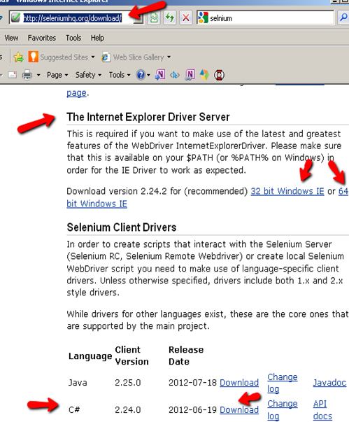

* Once you’ve downloaded the required Selenium files, extract the zips to a local drive on your computer

FYI – the Selenium Web Drivers work against IE 6,7,8 and 9 both 32-bit and 64-bit versions.

* Launch Visual Studio and start a new project
* Select ‘Console Application’ and name your project mySelenium
* Next select Project>Add References from the tool bar and browser to the location where you extracted the Selenium dlls to. (Also be sure to select the correct version of .NET)

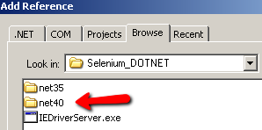

* Select all the dlls and click ok

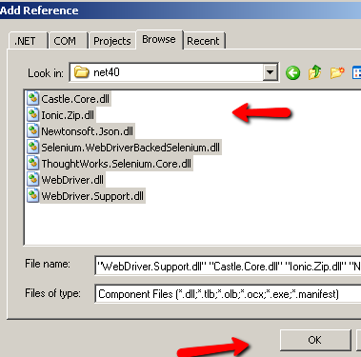

namespaces:

**using OpenQA.Selenium;**

**using OpenQA.Selenium.IE;**

**using OpenQA.Selenium.Support.UI;**

//!Make sure to add the path to where you extracting the IEDriverServer.exe:

**IWebDriver driver = new InternetExplorerDriver(@"C:\Download\IEDriverServer");**

**driver.Navigate().GoToUrl("http://www.joecolantonio.com/HpSupport.html");**

Run the test. joecolantonio.com should appear.

## How to Use the IE Developer Toolbar

If you are going to be scripting against IE you’ll want to install the [Internet Explorer Developer Toolbar](http://www.microsoft.com/en-us/download/details.aspx?id=18359). (Those familiar with QTP are aware that this is similar QTP’s spy tool)

Using the IE Dev’s Arrow feature allows you to spy on an element’s attributes. You can then use those attributes in your Selenium code to help identify fields in you web application.

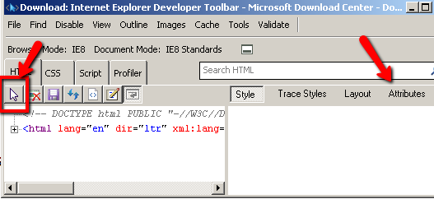

For example if we want to navigate to [www.joecolantonio.com/HpSupport.html](http://www.joecolantonio.com/HpSupport.html) and select a value from the ‘Select your tool & Version’ we would point the IE Dev arrow to the field to see its attributes:

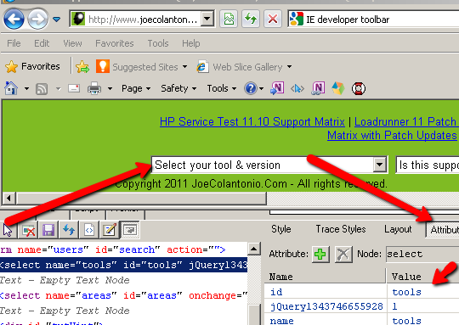

Now that we know what the Id is, we can use that information to help Selenium interact with it. For example:

myField = new driver.FindElement(By.Id("tools"));

myField.SendKeys("QTP10");

Run the test. It should start IE , navigate to http://www.joecolantonio/HPSupport.Html and select QTP10 from the Select your tool & version.

## Common Selenium IE issues to look out for

If you getting the following error:

“InvalidOperationException was unhandled – unexpected error launching Internet Explorer. Protected Mode setting are not the same for all zones.

Enable Protected Mode must be set to the same value (enabled or disabled) for all zones”

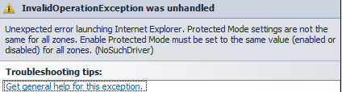

In IE tools>Internet Options>Security tab, make sure all your zones are set to the same value:

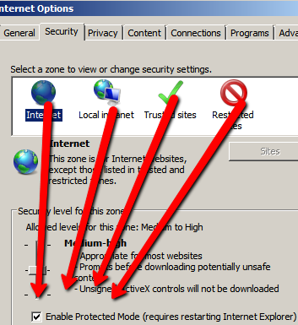

If you are getting the following error:

“DriverServiceNotFoundException was unhandled: The file … \IEDriverServer.exe does not exist. The driver can be downloaded at”

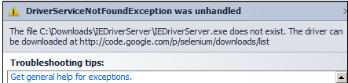

Make sure that you downloaded the [IEDriverServer.exe](http://seleniumhq.org/download/) and also that you have the correct path specified in your code

<em>IWebDriver driver = new InternetExplorerDriver(@"C:\YourPath\IEDriverServer");

</em>